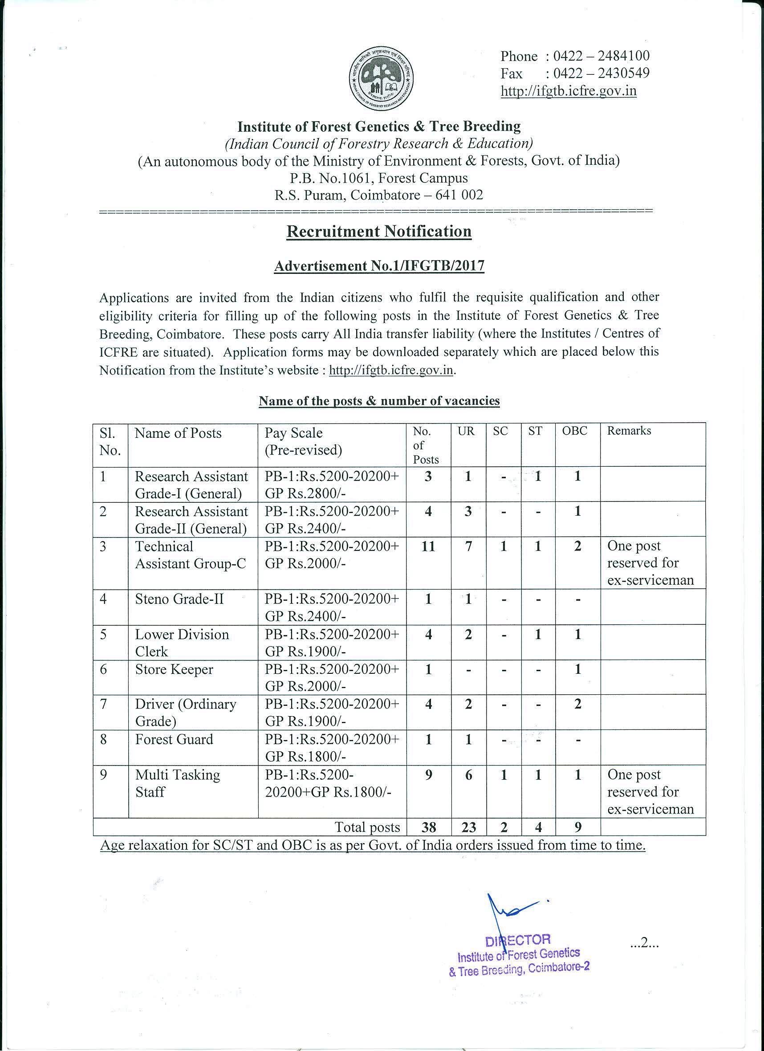

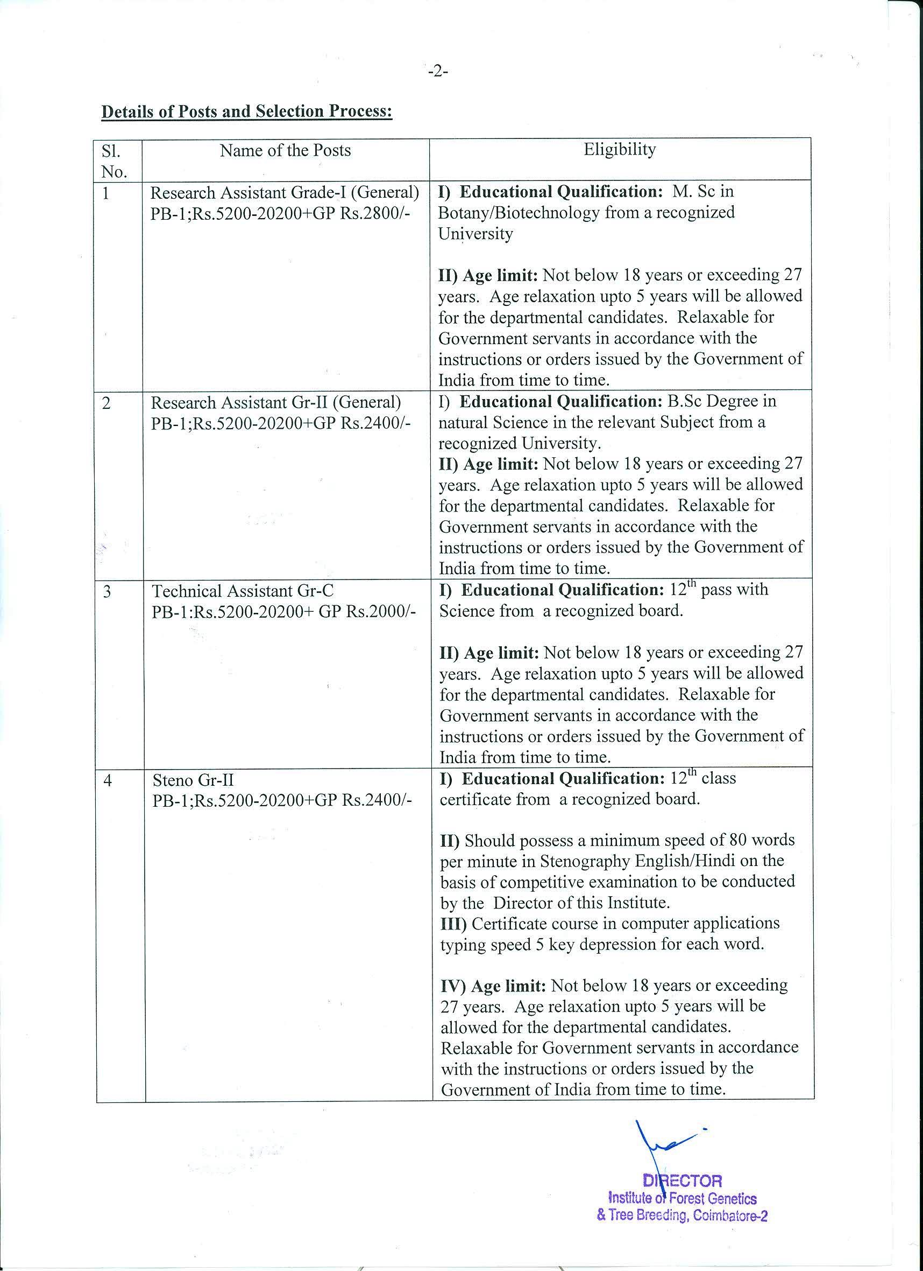

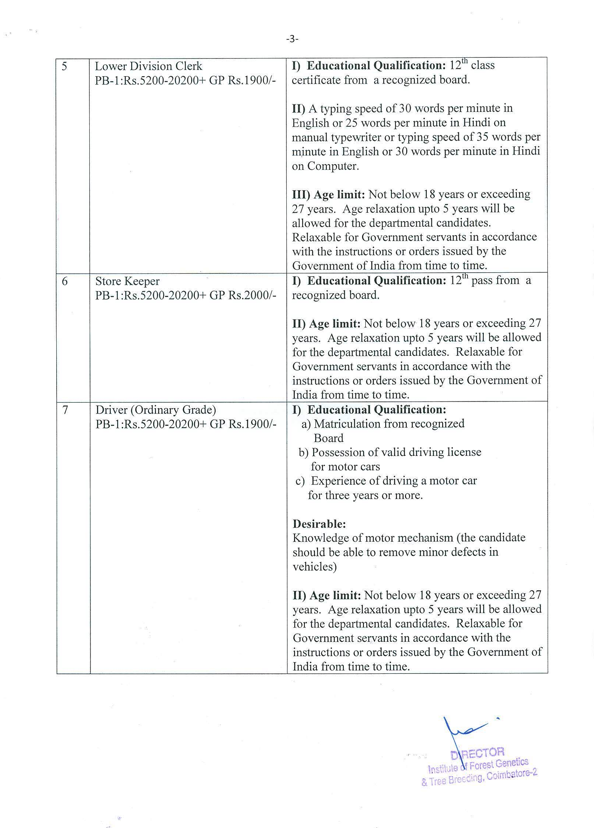

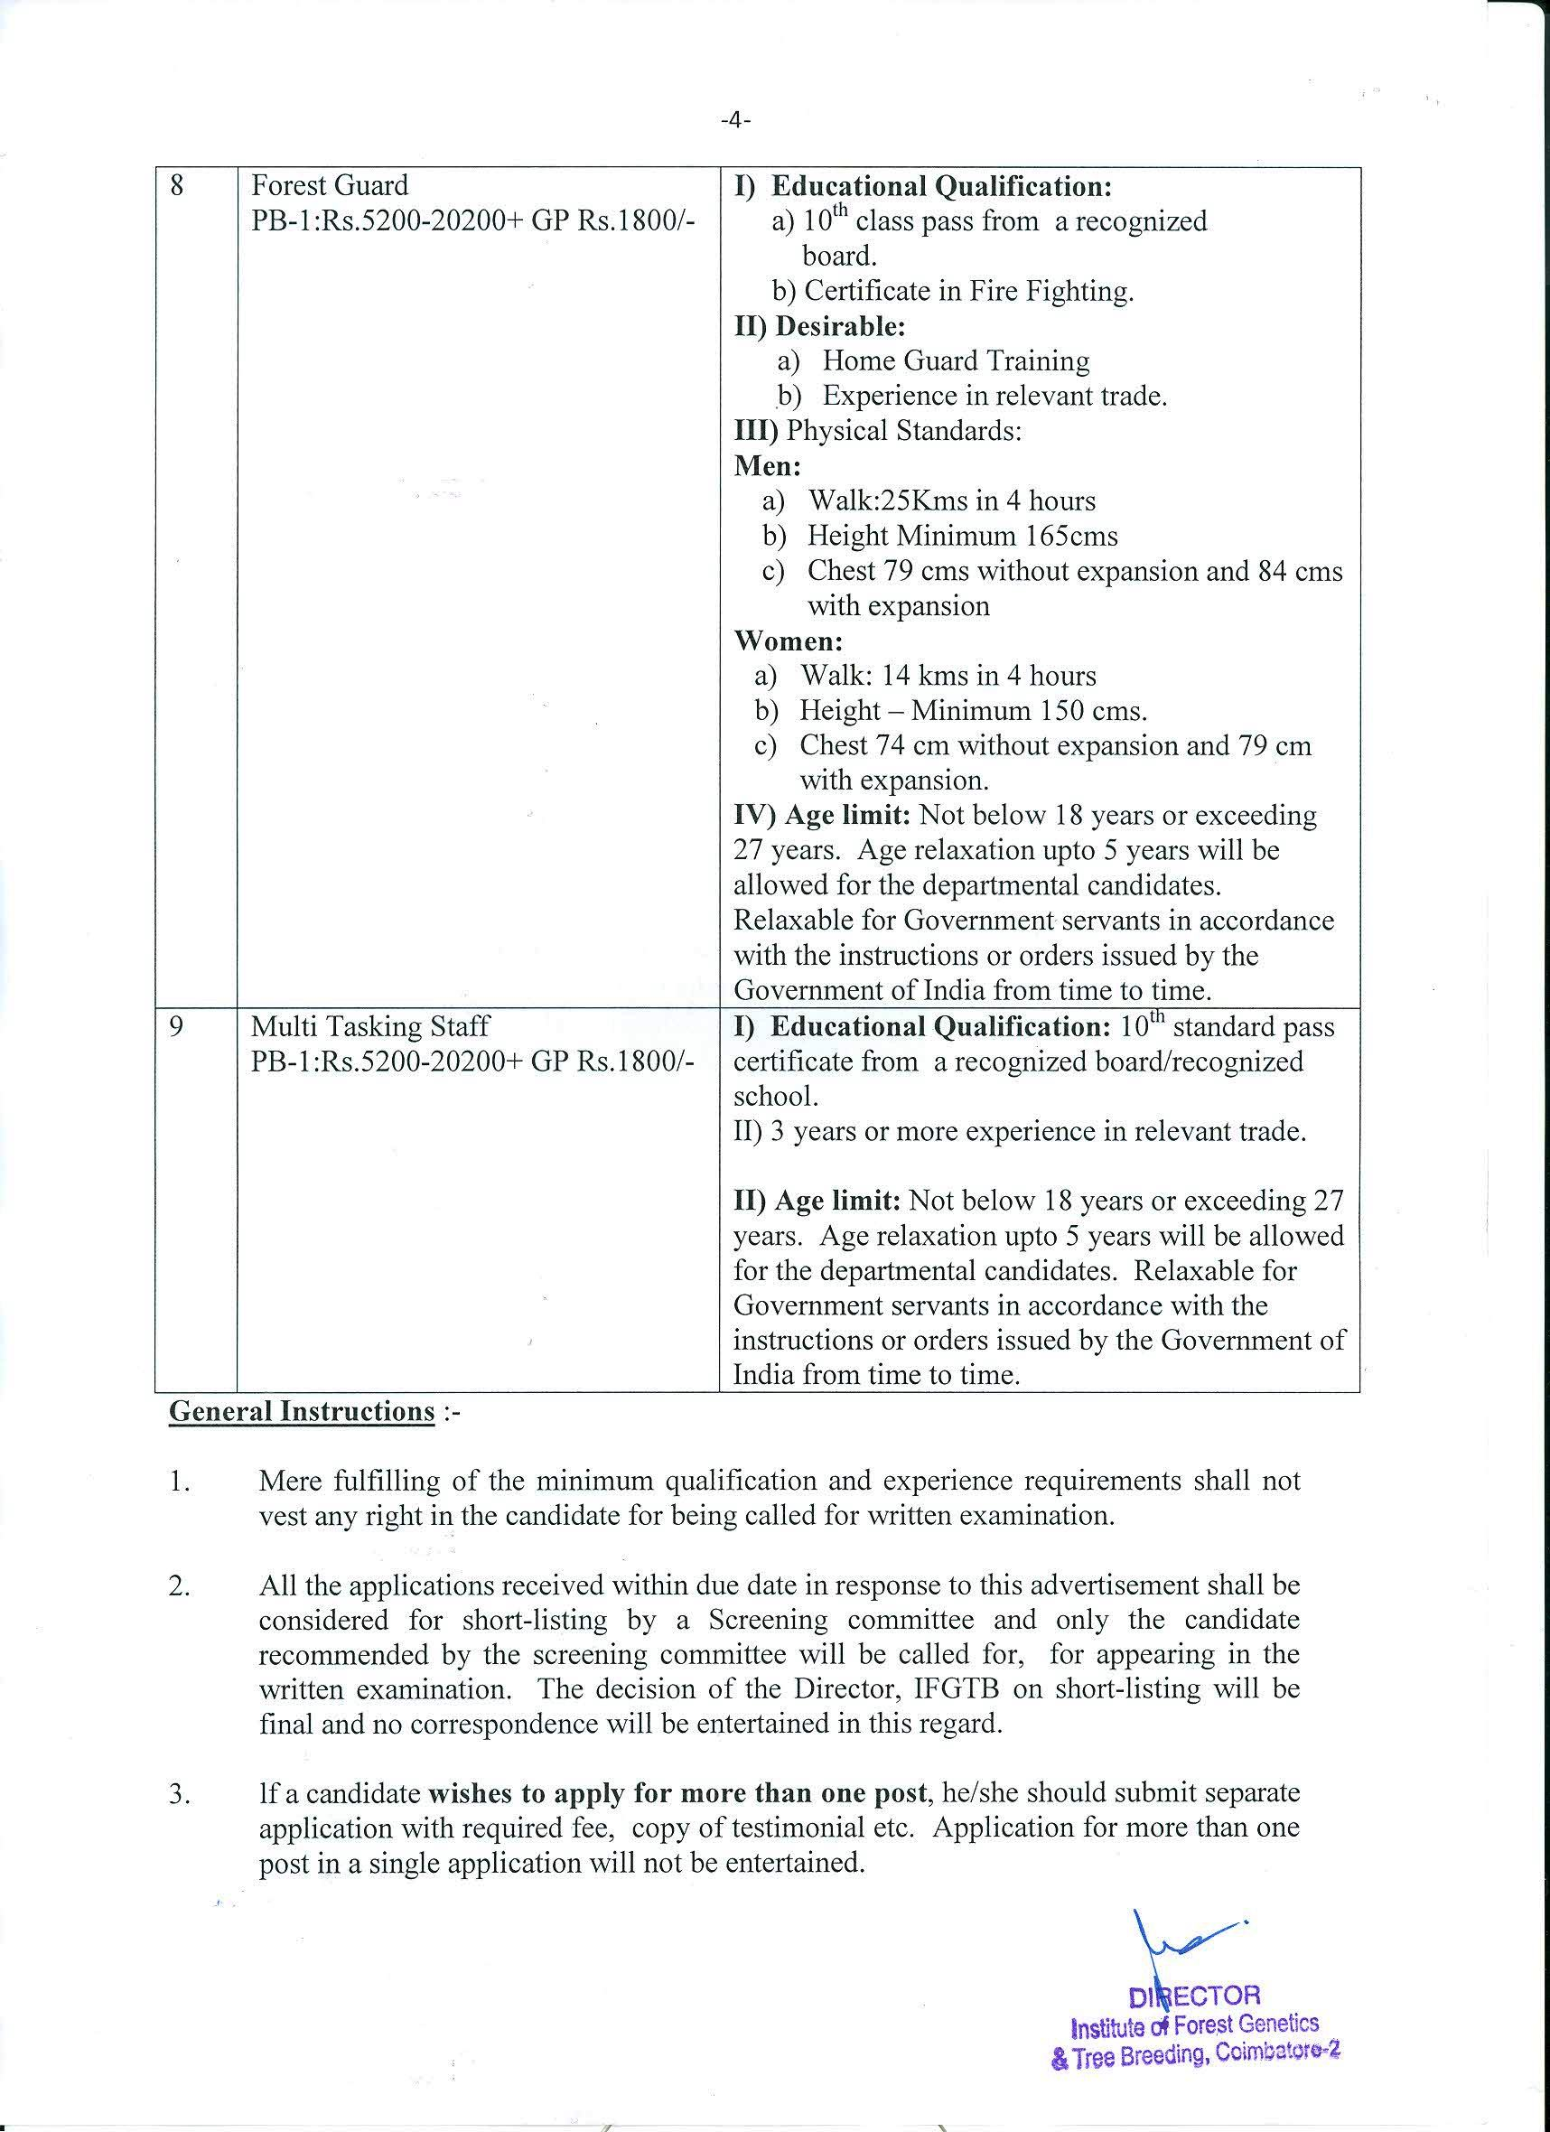

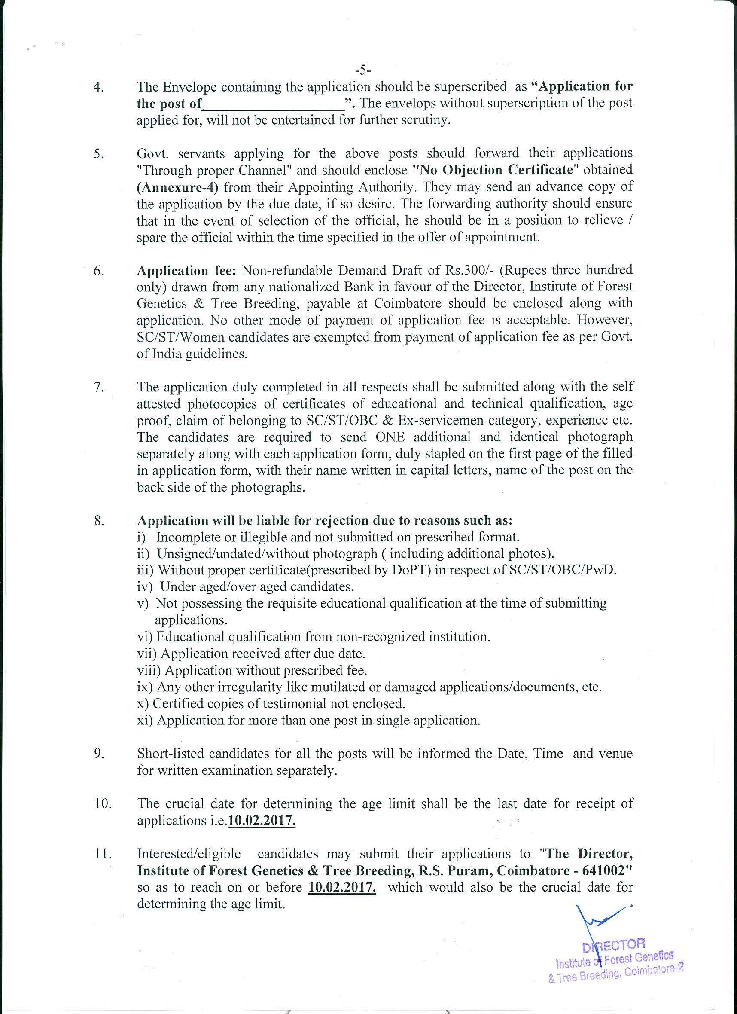

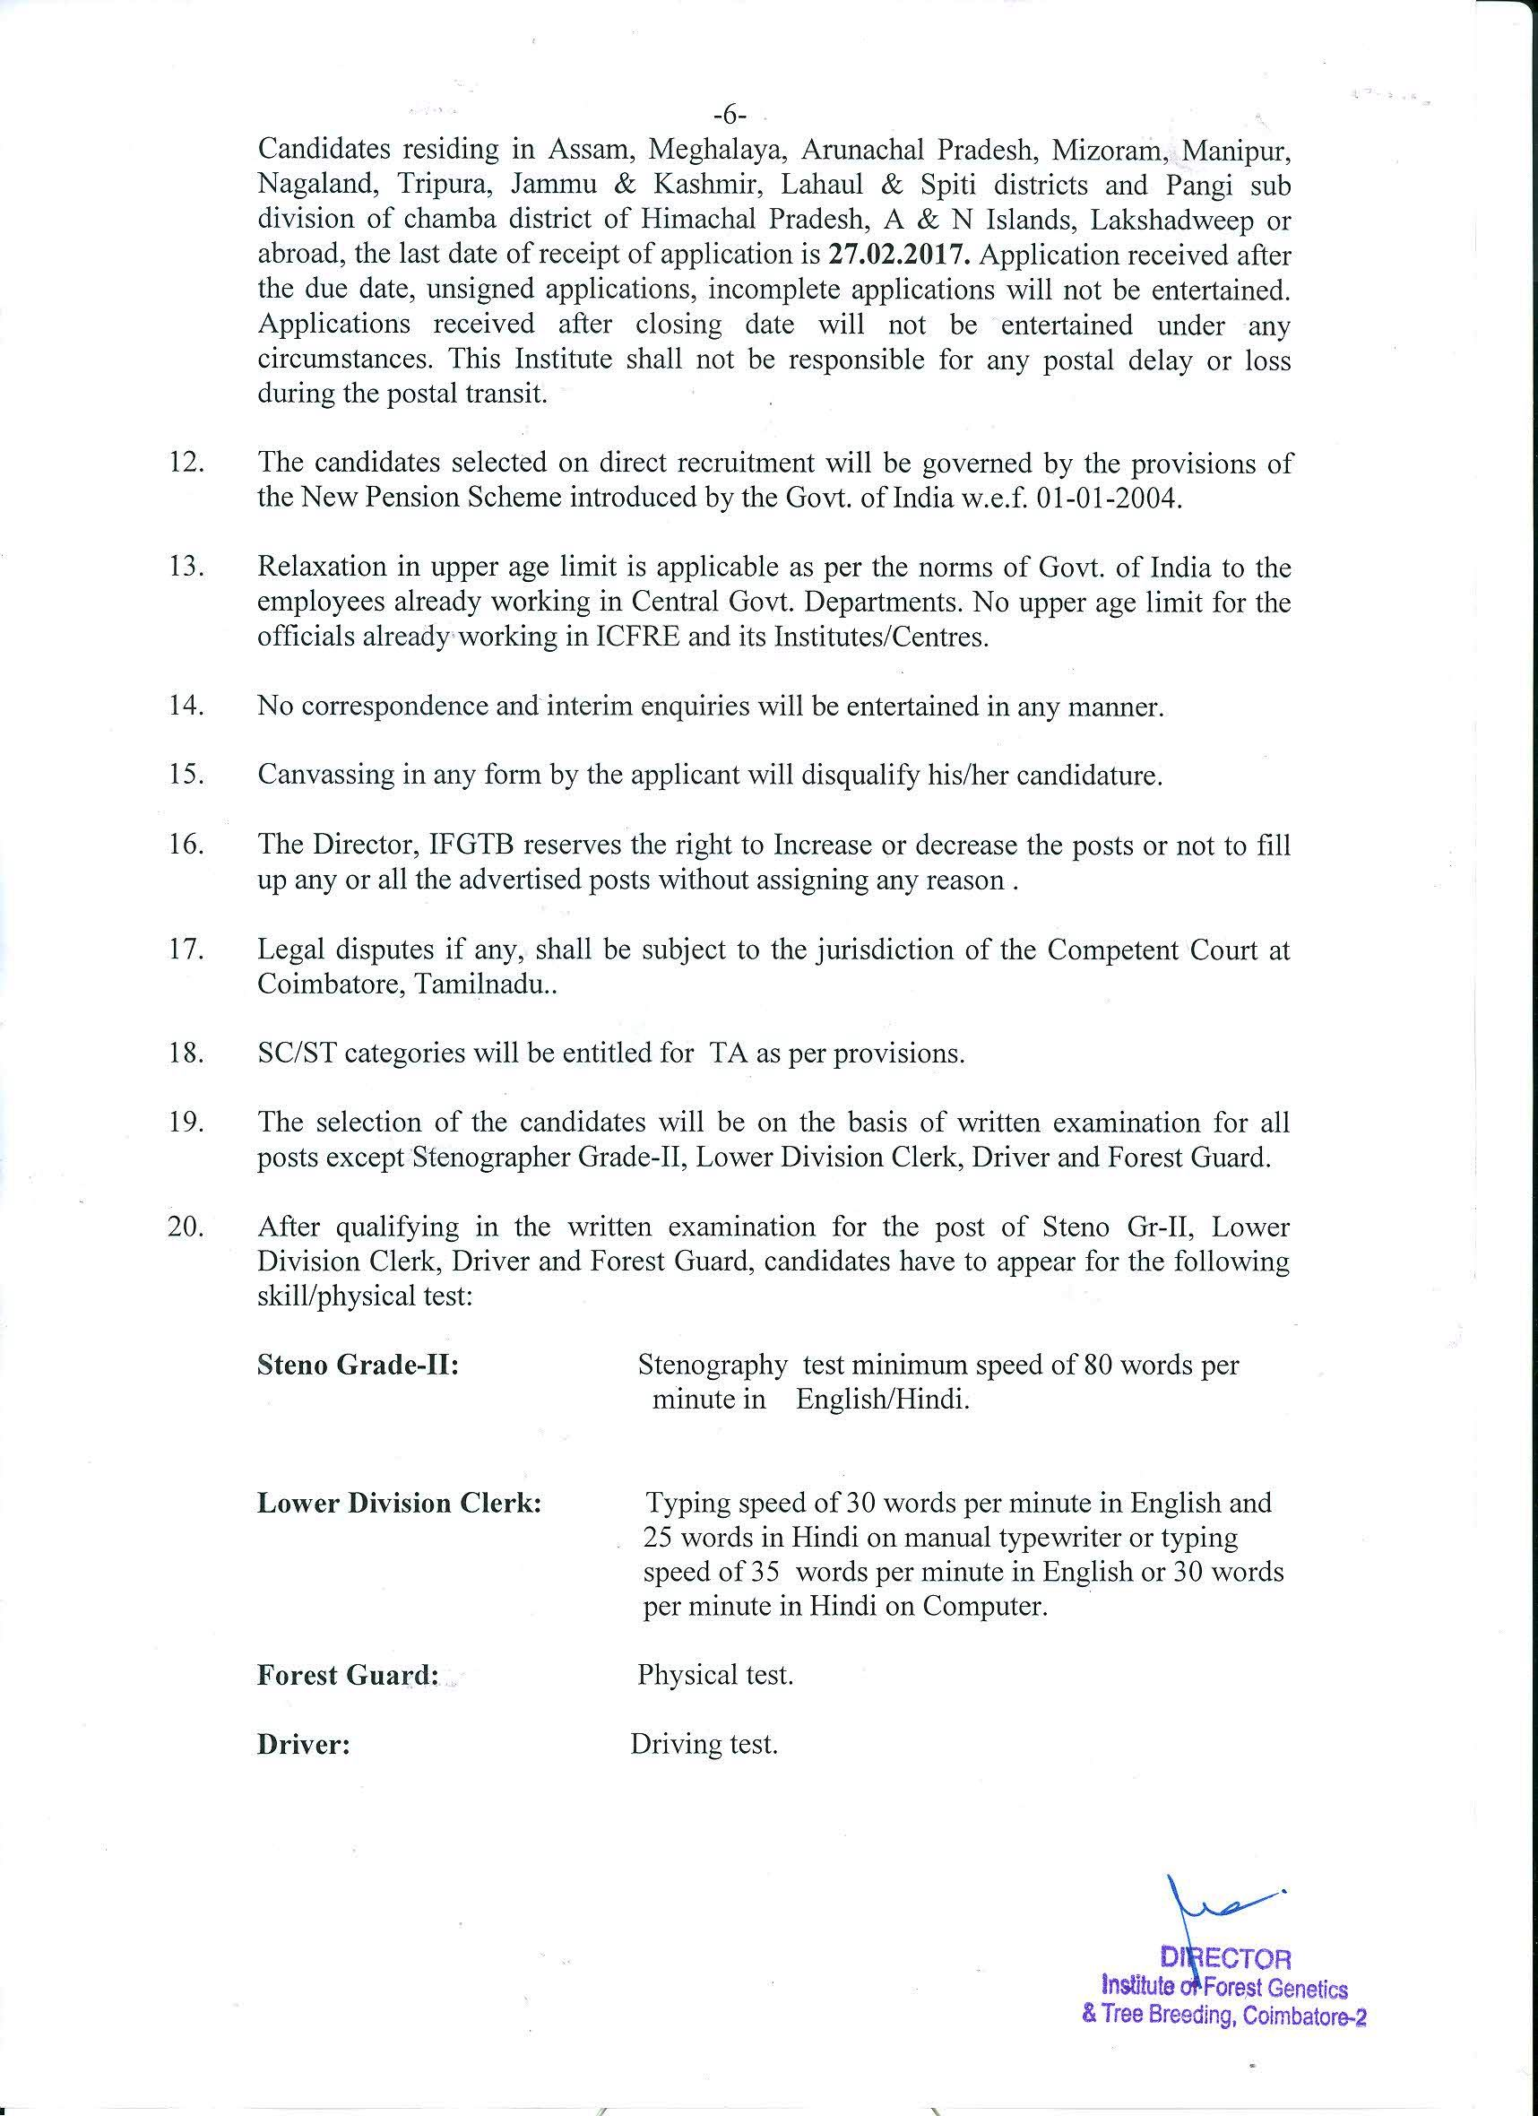

Institute of Forest Genetics & Tree Breeding
(Indian Council of Forestry Research & Education)
(An autonomous body of the Ministry of Environment & Forests, Govt. of India)
R.S. Puram, Coimbatore – 641002
------------
Format of the Application Form
Affix self attested passport size photograph

Application for the Post of _______________________________________
1. Advertisement No. :
2. Amount of Application Fee : Rs ...................D .D. No........................Date .............
Name of Bank ..................................................................................................................

3. Name of Applicant (in Block Letters): ..................................................................................
4. Father's / Husband Name :
5. Date of Birth :
6. Age as on 10.02.2017: .........................Years ...................Months..................... Days
7. Nationality :
8. Whether SC/ST/OBC/PWD (Specify):
9. Sex: Male / Female :
10. Address for correspondence :
11. Mobile No. / e-mail address :
12. Aadhaar No. :
13. Educational qualification :
Exam Passed | Year | Board / School
14. Experience if any :

15. I hereby declare that the above information is correct to the best of knowledge and belief that nothing has been concealed or distorted. If any time, I am found to have concealed/ distorted any material information, my appointment shall be liable for termination.

Place: Signature of Candidate
Date:

Appendix-1

APPLICATION FORM FOR GROUP 'C'
(Retired Defence Service Personnel)
Please paste your passport size photograph (in uniform)

1. Personnel number, Rank and Name :
2. Arm/ Service :
3. Father's Name :
4. Dates of —
(a) Birth :
(b) Enrolment :
(c) Retirement / Discharge :
5. Reasons for Release / Discharge :
6. Medical Category :
7. Award or Decoration :
8. Home, District and State :
9. Present Address/ Mailing Address :
10. Permanent Address :
11. Present profession employment :
12. Qualification: (Please attach attested copies of mark sheets)
Course | Year | Institution | Civil Equivalent
(a) Civil (Education)
(b) Military (Education)
(c) Military (Profession)

13. *Languages known - Read/Write/Speak
(a) Indian :
(b) Foreign :

*Applicable where applications are not made directly.

14. * Character as assessed by Military authorities
15. Extra-curricular activities-
(a) Sports :
(b) Literary :
(c) Cultural/Art :
16. Details of pay/pension/gratuity-
(a) Last basic pay drawn :
(b) Total emoluments :
(c) Details of pension/gratuity :
17. Zilla Sainik Board/Employment Exchanges:
(Registration No.)
18. Job applied for
Date ( ...............................................)
Signature
Name
Address

*Countersigned
_____________________________________________________________________________
* Applicable where applications are not made directly.

Appendix-2
PRO FORMA OF CERTIFICATE FOR EMPLOYED OFFICIALS
G.I., Dept. of Per. & Trg., O.M. No.36034/2/91-Estt.(SCT), Dated 03-04-1991

I hereby, with the information available, certify that Shri ................................................(Name) No.............................................. (Rank) would complete prescribed period of appointment on ..................................(Date)
Place: Signature
Dated: Commanding Officer
Office Seal

Appendix-3
FORM OF UNDERTAKING TO BE GIVEN BY CANDIDATES APPLYING FOR CIVIL POSTS UNDER EX-SERVICEMEN CATEGORY
G.I., Dept. of Per. & Trg., O.M. No.36034/2/91-Estt.(SCT), Dated 03-04-1991

I understand that, if selected on the basis of the recruitment/examination to which this application relates, my appointment will be subject to my producing documentary evidence to the satisfaction of the Appointing Authority that I have been duly released/retired/discharged from the Armed Forces and that I am entitled to the benefits admissible to ex-servicemen in terms of the Ex-Servicemen (Re-employment in Central Civil Services and Posts) Rules, 1979, as amended from time to time.
2. I also understand that I shall not be eligible to be appointed to a vacancy reserved for Ex-servicemen in regard to the recruitment covered by this examination, if I have at any time prior to such appointment, secured any employment on the civil side (including Public Sector Undertakings, Autonomous Bodies/Statutory Bodies, Nationalized Banks, etc.), by availing of the concession of reservation of vacancies admissible to Ex-servicemen.

Place: Signature of Candidate
Date:

Annexure-4
(in the case of Govt. employees)

Certificate to be furnished by the Employer / Forwarding Authority certified that :
- The particulars furnished by Shri/Smt. ______________________________ are correct.
- There is no vigilance / disciplinary case either pending or contemplated against him/here.
- Integrity of the applicant is certified.
- Photocopies of the up-to-date ACRs, attested by an officer not below the rank of an Under Secretary to the Govt. of India are enclosed.

Date : (Signature of the Head of the Department / Forwarding Authority)
Department/Office with seal
Telephone No._________________

Annexure-5
FORM OF SCHEDULED CASTE/TRIBE CERTIFICATE

This is to certify that Slui/Shrimati*/Kumari* _______________________ son/daughter* of ______________________ village/town* ______________________ in District/Division* __________________________________ of the State/Union Territory*________________ belongs to the ___________________ Caste/Tribe which is recognized as a Scheduled Caste/Scheduled Tribe* under:
*The Constitution (Scheduled Castes) Orders, 1950: *The Constitution (Scheduled Tribes) Order, 1950; *The Constitution (Scheduled Tribes) (Union Territories) Order, 1950; *The Constitution (Scheduled Tribes) (Union Territories) Order, 1951: {as amended by the Scheduled Castes and Scheduled Tribes List (Modification Order, 1956, the Bombay Recoganisation Act, 1960, the Punjab Recoganisation Act, 1966, the State of Himachal Pradesh Act, 1970, the North Eastern Areas (Recognisation) Act, 1971 and the Scheduled Castes and Scheduled Tribes Orders (Amendment) Act, 1976} *The Constitution (Jammu and Kashmir) Scheduled Order, 1956; *The Constitution (Andaman and Nicobar Islands) Scheduled Tribes Order, 1959 as amended by the Scheduled Castes and Scheduled Tribes Orders (Amendment) Act, 1976; *The Constitution (Dadra and Nagar Haveli) Scheduled Castes Order, 1962; * The Constitution (Dadra and Nagar Haveli) Scheduled Tribes Order, 1962; *The Constitution (Pondicherry) Scheduled Castes Order, 1964; * The Constitution (Scheduled Tribes) (Uttar Pradesh) Order, 1967; * The Constitution (Goa, Daman and Diu) Scheduled Castes Order, 1968; * The Constitution (Goa, Daman and Diu) Scheduled Tribes Order, 1968; * The Constitution (Nagaland) Scheduled Tribes Order, 1970. * The Constitution (Sikkim) Scheduled Tribes Order, 1978. *The constitution (Jammu and Kashmir) Scheduled Tribes Order, 1989. *The constitution (Scheduled Castes) Orders (Amendment) Act, 1990. *The Constitution (Scheduled Tribes) Orders, amendment Act, 1991. *The Constitution (Scheduled Tribes)order Sceond Amendment Act, 1991.
2. This certificate is issued o the basis of the Scheduled Castes/Scheduled Tribes Certificate issued to Shri/Shrimati*/Kumari* _____________________________father/mother of Shri/Shrimathi/Kumari____________ of village/town_______________ in District/Division ___________of the State/Union Territory___________ who belongs to the Caste/Tribe which is recognised as Scheduled Caste/Scheduled Tribe in the State/Union Territory________ issued by the ____________dated____________.

3. Shri/Shrimathi/Kumari________________ and or his/her family ordinarily reside(s) in village/town ____________of ________________ District/Division of the State/Union Territory of_____________.
Signature ________________
Designation _____________________
(with seal of office) State/Union Territory
Place _________________
Date __________________

Annexure-6
FORM OF CERTIFICATE TO BE PRODUCED BY OTHER BACKWARD CLASSES APPLYING FOR APPOINTMENT TO POSTS UNDER THE GOVERNMENT OF INDIA
This is to certify that Shri/Smt/Kumar ____________________ son/daughter of __________________ of village/town _________________________ in District/division ____________ in the State/Union Territory _______________ belongs to the __________________ community which is recognised as a backward class under the Government of India, Ministry of Social Justice and Empowerment’s Resolution No._____________________________ dated _______. Shri/Smt/Kumari ____________________ and /or his/her family ordinarily reside(s) in the ________________________ District/Division of the ____________________ State/Union Territory. This is also to certify that he/she does not belong to the persons/sections (Creamy layer) mentioned in Column 3 of the Scheduled to the Government of India, Department of Personnel & Training O.M. No.36012/22/93-Estt(SCT) dated 08.09.1993.

District Magistrate
Deputy Commissioner etc
Dated:

Seal.

